Sprint 4 Plan - PYP - 5/19/26 - Version 1.0 - 5/19/26
Sprint 4 Plan - CSE 115a – Intro to Software Engineering
Goal
This is our last build sprint. The app lets users log in with Spotify, view playlists, and get individual song prices through Discogs. This sprint we finish the buying experience: detecting when songs share an album so we can show both album and individual prices, adding a second API so we find physical links for at least 80% of songs, making API calls run in parallel to cut loading screens, letting users pull a link for a single song, and finishing the physical format option we didn’t get to in Sprint 3.
Tasks
User Story 1 (“As a user, I want to have an option of buying an album or a set of songs”) ● Task 1: Detect when two or more songs in a playlist are from the same album (2 hours)
● Task 2: Create a method that pulls the album price as well as the individual prices (1.5 hours)
● Task 3: Add a selection tool so the user can choose album or individual prices (1.5 hours)
- Total: 5 hours
User Story 2 (“As a user, I want direct links to storefronts for >80% of songs”) ● Task 1: Research and pick a second API to use alongside Discogs (1.5 hours) ● Task 2: Write a method that queries the new API and returns a physical link (2 hours) ● Task 3: Add fallback so the second API is used when Discogs has no link (1.5 hours) - Total: 5 hours
User Story 3 (“As a user, I want to quickly see results so that I don’t wait on long loading screens”)
● Task 1: Make the playlist pricing method run API calls in parallel (3 hours)
● Task 2: Add a progress indicator that fills in as results come back (1 hour) - Total: 4 hours
User Story 4 (“As a user, I want to retrieve a link for a single song”)
● Task 1: Add an access tool to look up one song (30 minutes)
● Task 2: Create a page that displays the song, album cover, price, and link (1.5 hours) - Total: 2 hours
User Story 5 (“As a user, I want to be able to choose the format for the physical media”) ● Task 1: Create a button/access tool for choosing format (30 minutes)
● Task 2: Create a page with the different available options -> modify from the top 5 method in user story 2 (1 hour)
Sprint 4 Plan - PYP - 5/19/26 - Version 1.0 - 5/19/26
● Task 3: Create/Modify a method that searches discogs, and handles the different edge cases and returns/displays errors if not possible (3 hours)
- Total: 4.5 hours
Team Roles
● Kaan - Scrum Master {Developer}
● Richard - Product Owner {Developer}
● Vanessa - Developer
● Victor - Developer
● Abner - Developer
Initial Task Assignment
● Kaan - User Story 1 - Task 1
● Richard - User Story 2 - Task 1
● Vanessa - User Story 3 - Task 1
● Victor - User Story 4 - Task 1
● Abner - User Story 5 - Task 1
Initial Scrum Board
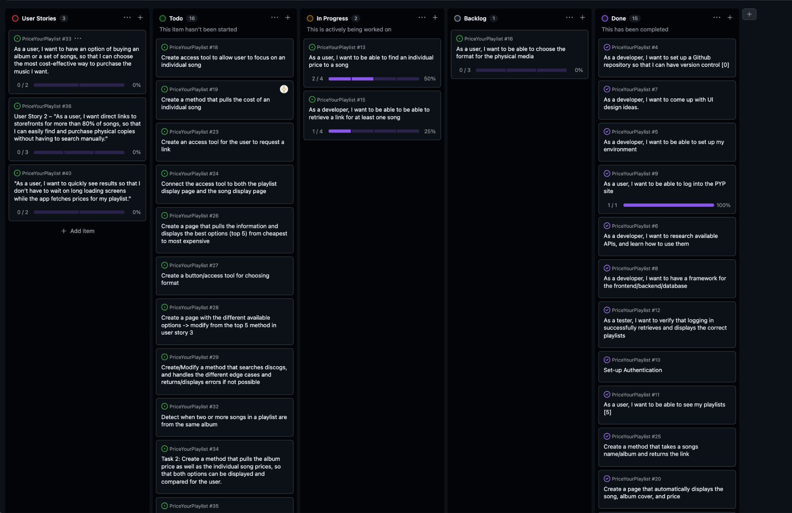

Scrum Times
● Tuesday 5/19 - 4pm - Group Meeting
● Thursday 5/21 - 4pm - Group Meeting
● Tuesday 5/26 - 4pm - Group Meeting
● Thursday 5/28 - 4pm - Group Meeting
● Wednesday 5/20 - 11:30am - TA Meeting

